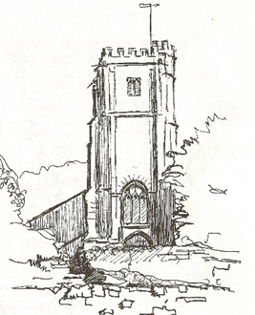**Askerswell Church**

Did you know the church is registered with EasyFundraising? This is the UK’s biggest charity shopping site. Since the church first registered £493 has been raised. It sends any donations raised directly to the church every quarter.

Make a difference to Askerswell Church with every online shop you do!

If you would like to sign up, please join today and you can raise free donations for Askerswell Church every time you shop online. Over 8,000 retailers like eBay, Argos, Marks and Spencer, John Lewis & Partners, Etsy, Tesco and Just Eat will donate at no extra cost to you. Sign up here:

<https://join.easyfundraising.org.uk/askerswellchurch/12DE6H/c2s/FZ9Up2Ac/CE947/facebook/>

***Other questions you may have:***

*How much do brands donate when I shop with them?*

Most brands pay a % of what you spend with them as a donation, for example if you spend £150 on a hotel via booking.com, they will donate 3% which is £4.50. Some retailers pay a flat amount, for example if you buy car insurance with confused.com via easyfundraising, they will donate a flat £15 regardless of the cost of the policy.

*Do you have a browser extension?*

Yes! Once you have an account set up on easyfundraising, you will have the option to install our browser extension which we call, our Donation Reminder. It will pop up on every retailer site where a donation is available which means you don’t have to remember to come to easyfundraising first!

*Do you have an App?*

Yes! You can download our App from the Apple or Google Play stores.

Thank you to anyone who does sign up – as they say every little helps.

Maggie Barrett

Treasurer of Askerswell PCC